**PSN ENGINEERING COLLEGE**



**DEPARTMENT**

**OF**

**ELECTRONICS AND COMMUNICATION ENGINEERING**

**TOPIC**

**IOT BASED SMART CROP PROTECTION**

**FOR AGRICULTURE**

**PROJECT MEMBERS**

**SRITHAMBIRATTI A - 952319106301**

**GUIDE NAME :-**

**Mrs.AMARASELVI V ,**

**ASSISTANT PROFESSOR,**

**DEPARTMENT OF ELECTRONICS &COMMUNICATION ENGINEERING**

**ABSTRACT**

This paper describes overview of various researches on smart crop protection system. We have a lot of technology that can protect the farm 24x7 those systems and technique included in this project. We have different types of technology that can help to secure the farm. We have seen Arduino and raspberry pi based Farm protection system. But those Systems have different mythology and platform for that and the cost of those projects also increased so that those are not affordable with the farmer. Our main aim to design a system that can help the farmer to protect his farm from, animals with getting harm to them. Keywords**:**SCPS, IOT, Arduino,Nodemcu.

## INTRODUCTION

Different strategies point just at observation which is fundamentally for human gatecrushers, however we will in general fail to remember that the fundamental foes of such farmer who trained the animals which literate the harvests. The issue of natural life assault on cropsi .ex., crop Canalization is getting extremely normal in the conditions of Tamil Nadu, Himachal Pradesh, Punjab, Haryana,Kerala and numerous different states. Wild creatures like monkeys, elephants, wild pigs, deer, wild canines, buffalo, nilgais,estray creatures like cows and wild oxen and even feathered creatures like parakeets cause a great deal of harm to crops by running over them eating and totally vandalizing them. This prompts helpless yield of harvests and huge monetary misfortune to the proprietors of the farmland. This issue is articulated to the point that occasionally the farmer choose to leave the territories barrendue to such incessant animal attacks.This framework causes us to fend off such wild animals from the farm lands and it is additionally an mechanized relying upon the need so that there is no manual work, subsequently saving time and likewise forestalling the deficiency of harvests. Consequently the model aides in better treatment of the yields viable. The client gets a better comprehension of theSS different states of his field and can handle them over his gadget from anyplace on the planet. Therefore we analyze which technology is suitable to protect the farm from animals.

**LITERATURE SURVEY**

**1.SMART CROPPROTECTION SYSTEM FROM LIVING OBJECTS AND FIRE USING ARDUINO**

This paper motive to designing and executing the superior improvement in embedded device for Crops in farms are over and over ravaged with the aid of nearby animals like buffaloes, cows, goats, birds, and fireplace etc. This results in huge losses for the farmers. It is now not feasible for farmers to barricade complete fields or precede field 24 hours and protect it. Therefore here we present computerized crop safety system from animals and fire. This is aArduino Uno primarily based device the use of microcontroller. This technique makes use of a motion sensor to discover wild animals drawing near the sphere and smoke sensor to discover the hearth. In such a case the sensor alerts the microcontroller to require action. The microcontroller now sounds an alarm to woo the animals away from the sector further as sends SMS to the farmer and makes call, in order that farmer may fathom the difficulty and come to the spot just in case the animals don’trecede by the alarm. If there's a smoke, it immediately turns ON the motor. This provide us entire safety of plants from animals and from fireplace for this reason protecting the farmer’s loss.

## 2 .REVIEW ON IOT IN AGRICULTURAL CROP PROTECTION AND POWER GENERATION

Agriculture is that the science and artwork of cultivating plants. Agriculture performs most important position inside the economic development of our us of a and this can be the first occupation from a few years. so as to extend the productivity of the crops and to attenuate the expenses of agricultural practices we adopt smart agriculture techniques using IOT. The sensors are placed at different locations within the farm, by which the parameters is controlled using remote or through internet services and by interfacing the sensors operations are performed with microcontrollers. India is that the second most populated country. Power generation and supply is typically an unlimited problem. This paper mainly addresses power generation and rainwater harvesting as an influence generation method using energy together with crop protection.

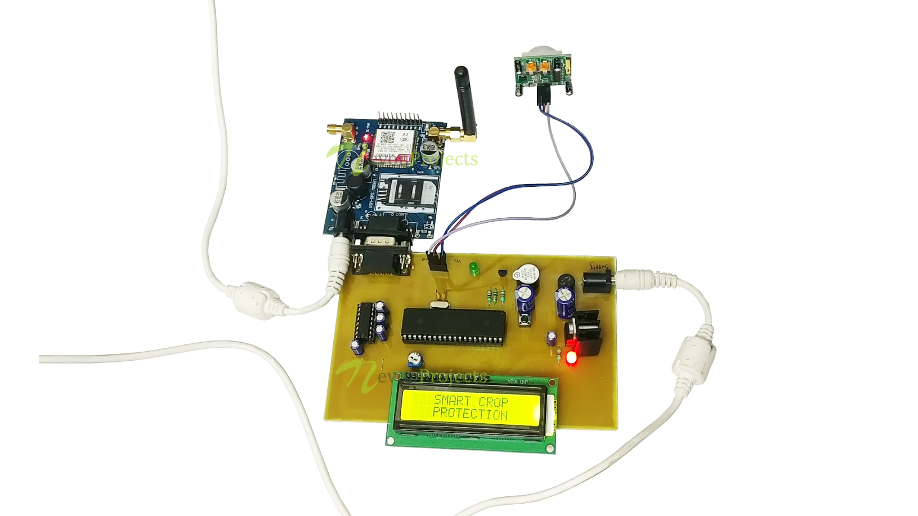

## 3.IOT BASED SMART CROP MONITORING IN FARM LAND

## As new technologies has been introduced and utilized in modern world, there is a need to bring advancement in the sector of agriculture also. Various Researches have been undergone to enhance crop cultivation and are widely used. So as to enhance the crop productivity efficiently, it is necessary to monitor the environmental conditions in and around the field. The parameters that has to be exact monitored to enhance the yield are soil characteristics, weather conditions, moisture, temperature, etc., Internet of Things (IOT) is being utilized in a number of real time applications. The introduction of Internet of thing (IOT) along with the sensor network in framrefurbishes the traditional way of farming. Online crop monitoring the use of IOT helps the farmers to stay related to his subject from somewhere and anytime. Various sensors are used to screen and collect records about the area conditions. Collectively the about the farm circumstance is disbursed to the farmer thru GSM technology.

## 

## 4.DEVELOPMENT OF IOT BASED SMART SECURITY AND MONITORING

## DEVICES FOR AGRICULTURE

Agriculture area being the backbone of the Indian economy deserves security. Security no longer in phrases of sources solely however additionally agricultural products wishes protection and safety at very preliminary stage, like protection from attacks of rodents or insects, in fields or grain stores. Such challenges should even be taken into consideration. Security systems which are getting used now a days don't seem to be smart enough to produce real time notification after sensing the matter.the mixture of typical methodology with present day technologies as Internet of Things and Wireless Sensor Networks can cause agricultural modernization. Keeping this scenario in our mind we've got designed tested and analyzed an 'Internet of Things' based device which is capable of analyzing the sensed information then transmitting it to the user. This gadget will be controlled and monitored from far off region and it is carried out in agricultural fields, grain shops and bloodless stores for protection purpose. This paper is oriented to intensify the methods to unravel such problems like identification of rodents, threats to crops and turning in actual time notification supported records evaluation and processing besides human intervention.During this device, referred to sensors and digital units are built-in using Python scripts. Supported attempted take a look at cases, we had been capable to obtain success in 84.8% check cases.

## 5. PROPOSED WORK

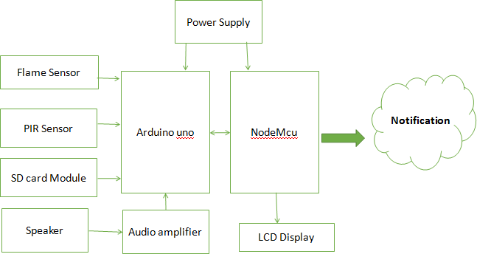

**Fig5.1: Block diagram of purpose syste**m.

Our project is smart crop protection system Using Arduino. This project is helpful for the farmer to protect his farm from animals and unknown person near to his farm. We are use PIR sensors for sensing the movement at the boarder of farm and that data will be given to Arduino after processing it can be display on lcd display. But we it is not sufficient to protect the farm hence we can add dog sounds via speaker so that the animals are not come inside the faram.

We are interface nodemcu for message of alert. When any movement detect then we have a message on our register Android phone. This project is fully works on free energy i.e. solar energy is store at battery. The battery is connected to our system hence we don't require to give another power supply.

We have added new feature to protect our farm by another issue. When the fire on our farm then we have received a fire message. So this is very protective and costly project. Hence because of our project the farmer can check the security and get immediate action.

## 6.HARDWARE REQUIREMENT

* Arduino Uno
* NodeMcu
* Flame sensor
* PIR sensor
* SD card module
* Speaker
* Connecting wires
* PCB
* Solar panel
* 12volt dc battery

**7.CONCLUSIONS**

From this literature survey we have seen lots of technology that help to farmer for to protect his farm. Specially IOT based system who can monitor the farm online. In above research papers they are not looking cost of System and so that didn’t get affordable to every farmer. Hence we want implement a costless smart crop protection system.

## 8.REFERENCES

1. Dr.M. Chandra ,Mohan Reddy, KeerthiRajuKamakshiKodi, BabithaAnapalliMounikaPulla, “SMART CROP PROTECTION SYSTEM FROM LIVING OBJECTS AND FIRE USING ARDUINO”, Science, Technology and Development, Volume IX Issue IX ,pg.no 261-265,Sept 2020.
2. Anjana ,Sowmya , Charan Kumar , Monisha , Sahana, “ Review on IoT in Agricultural Crop Protection and Power Generation”, International Research Journal of Engineering and Technology (IRJET) , Volume 06, Issue 11,Nov 2019.
3. G. NaveenBalaji, V. Nandhini, S. Mithra, N. Priya , R. Naveena, “IOT based smart crop monitoring in farm land ”,Imperial Journal of Interdisciplinary Research (IJIR), Volume 04, Issue 01 , Nov 2018.
4. P.Rekha, T.Saranya, P.Preethi, L.Saraswathi, G.Shobana, “Smart AGRO Using ARDUINO and GSM”, International Journal of Emerging Technologies in Engineering Research (IJETER) Volume 5, Issue 3, March 2017.
5. TanmayBaranwal”Development of IOT based Smart Security and Monitoring Devices for Agriculture”,Department of Computer Science Lovely Professional University Phagwara, Punjab, IEEE-2016.